Quantitative Chemistry
Moles and Stoichiometry
What is mole? Mole is the unit (just like g or s or cm) of amount of a substance. It is one of the seven SI standard physical units. Chemical amounts are measured in moles. The symbol for the unit mole is mol. A mole is defined as
The relative formula mass of a substance, in grams, that contains exactly 6.02x10²³ particles/atoms/molecules/ions, is known as one mole of that substance.
A_{r} relative formula mass the av mass of the isotopes of an element compared to 1/12th of the mass of an atom of carbon- 12.
M_{r} or relative molecular mass = the sum of relative atomic masses of individual elements.
A mole contains 6.02x10²³ particles, this number is known as Avogadro’s constant.
One lithium or magnesium atoms has ^^ moles but we don’t deal with singular atoms. We deal with compounds and mixtures.
Review: what is Ar and Mr?
The mass of one mole of a substance in grams is numerically equal to its relative formula mass. (e.g., the Ar of iron is 56, so one mole of iron weighs 56g or the Mr of nitrogen gas, N₂, is 28 (2 x 14), so one mole is 28g).
Moles can be calculated using either mass of the substance, volume of gas, or concentration of the liquid solution.
Use of amount of substance in relation to masses of pure substances
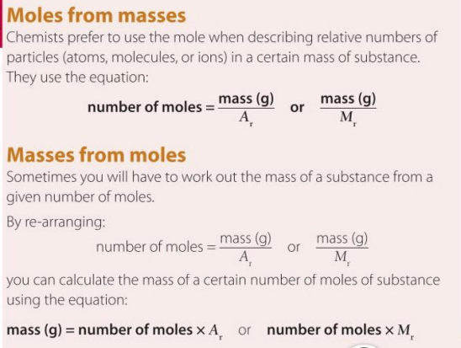
You can convert between moles and grams by using this triangle (you may have to rearrange it).
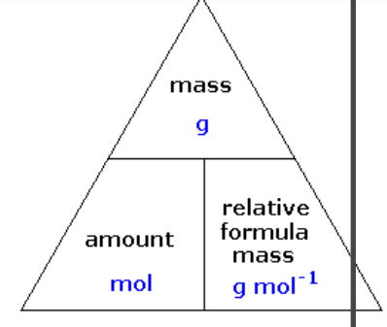
Mole = mass of a substance/ molecular mass of a substance (Mr)
This equation shows that more the mass of the substance more the moles and the more the Mr the lesser the moles
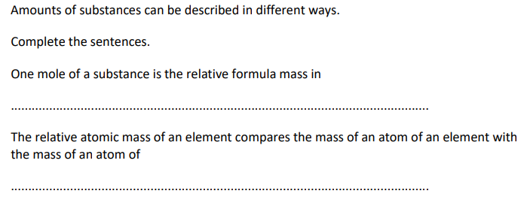
Grams C-12
QS. What are the molecular weights of the following compounds
- NaOH B) H₂O C) Mn₂Se₇ D) (NH₄)₂SO₄
QS.
How many moles are there in 22 grams of argon? 22/40 = 0.55
How many grams in 88.1 moles of magnesium?
How many moles in 2.3 grams of phosphorus?
How many grams in 11.9 moles of chromium?
How many moles in 68 grams of copper (II) hydroxide, Cu (OH)₂?
How many grams in 0.02 moles of beryllium iodide, BeI₂?
Be careful about significant figures!

Use of amount of substance in relation to volumes of gases
Equal amounts (in mol.) of gases occupy the same volume under the same conditions of temperature and pressure (RTP) Avogadro’s law
Volume of 1 mol. of any gas at RTP (room temperature and pressure: 20 degrees C and 1 atmosphere pressure) is 24dm³
This sets up the equation: Volume of gas (dm³) at RTP (24) or STP (22.4) (standard temperature and pressure)
Volume = Moles x 24
Moles = Volume of gas in cm³ /24000
Moles = Volume of gas in dm³ / 24
Using this equation, we conclude that more the volume of a gaseous substance more the moles and vice-versa (e.g., if you produce 5 moles of hydrogen, you produce 24 x 5 = 120 dm³) mole and vol are directly related
3 sf
24 dm3 = 24000 cm3
QS.
Calculate the volume of 3 moles of SO₂ sulfur dioxide at r.t.p 72
Calculate the volume of 0.55 moles of ammonia NH₄ at r.t.p 13.2
Calculate the volume of 0.045 moles of water vapors of at r.t.p
How many moles are there in 700 cm³ of hydrogen sulfide? 0.0292
How many moles are present in 2500 cm³ of N₂ gas?
How many moles are there in 0.5 dm³ of sulfur trioxide S0₃?
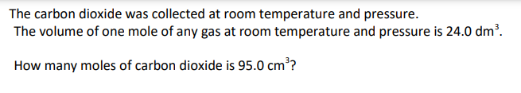
0.00396
1. 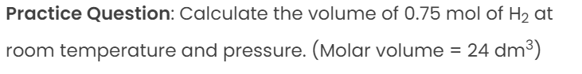
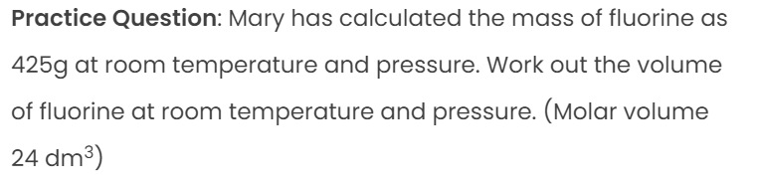
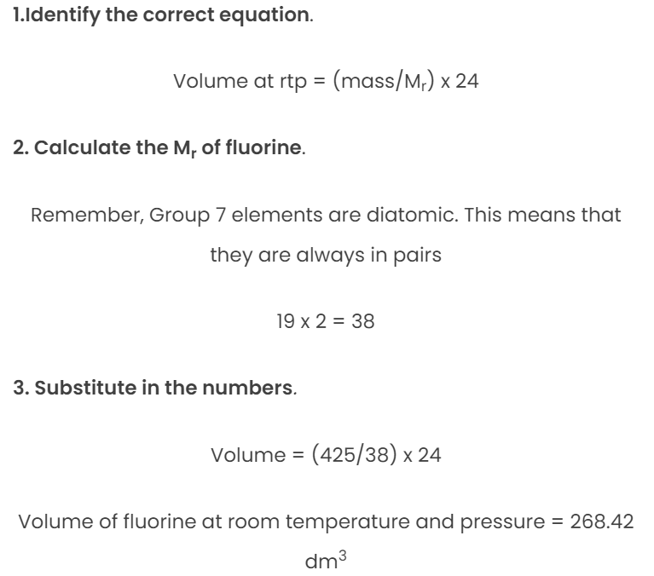
425/38=11.18 mol
11.18 x 24 = 268.42
F₂

Using concentrations of solutions in mol/dm³
Concentration of the solution is defined as the number of moles of substance present in 1 dm³ of solution or 1000 cm³ solution. The units are mol/dm³. (Used in titration exp)
Concentration = moles of a substance / 1000 cm³ of solution mol/1 dm
Moles = (Volume of solution x Concentration of solution) / 1000
Is mass of a solute related to concentration? How?
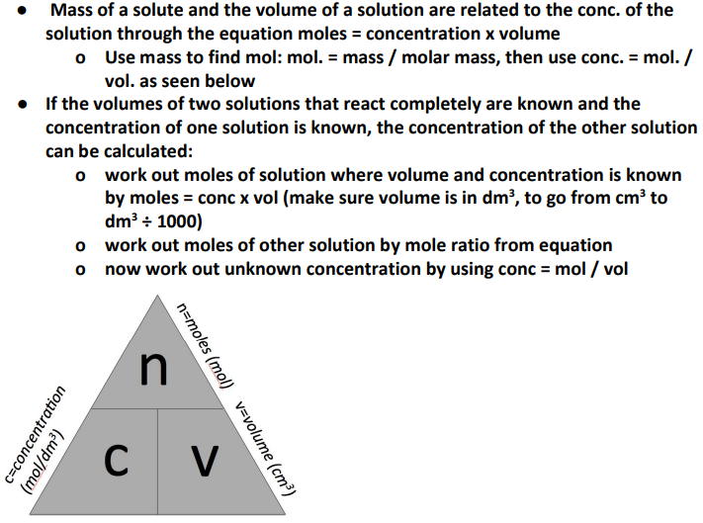
Concentration of a solution can be measured in mass per given volume of solution e.g., grams per dm3 (g/dm³)
To calculate mass of solute in a given volume of a known concentration use mass = conc x vol i.e.,
g = g/dm3 x dm3
a smaller volume or larger mass of solute gives a higher concentration
a larger volume or smaller mass of solute gives a lower concentration
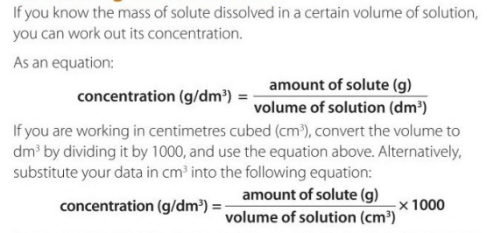
QS.
Calculate the moles of NaOH in 30 cm³ of 0.05 mol/ dm³ of NaOH solution. 1.67 mol
Calculate the moles of KOH in 15.6 cm³ of 0.6 mol/ dm³ of KOH solution. 38.5 mol
Calculate the volume of 0.05 mol/ dm³ solution that contains exactly 0.04 moles of NaOH solution.
Calculate the volume of 0.1 mol/ dm³ CaCl₂ solution that contains exactly 0.04 moles CaCl₂ solution.
Find the volume needed to contain exactly 0.006 moles of CuCl₂ if the concentration of the solution is 0.004 mol/ dm³.
25 grams FeSO₄ is dissolved to form a solution that contains 100 cm³ of FeSO₄.
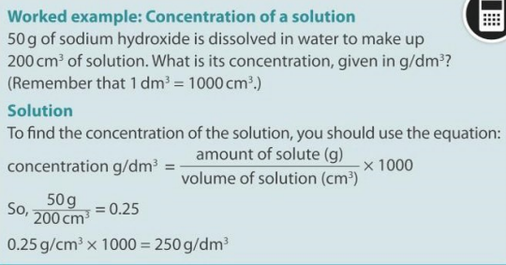
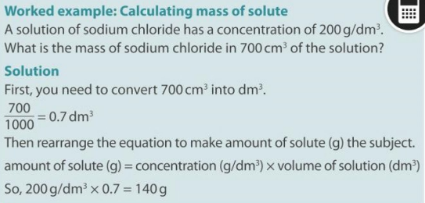
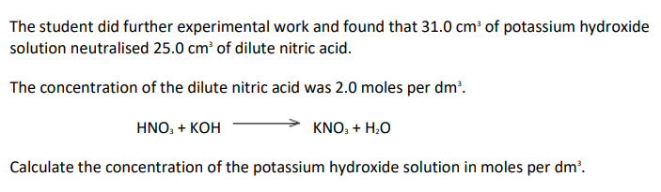
1.61
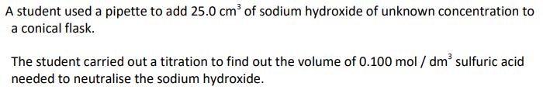
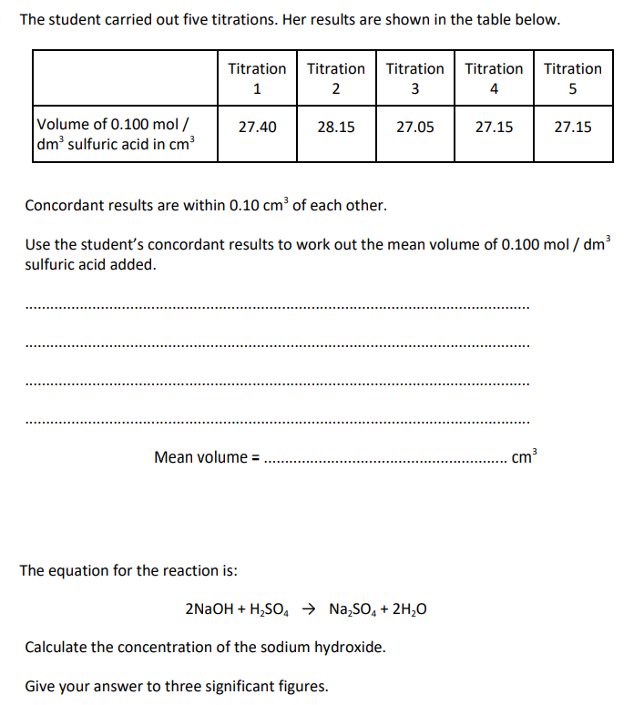
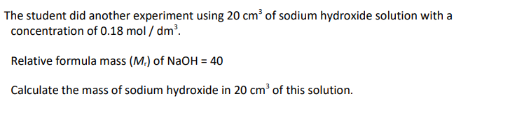

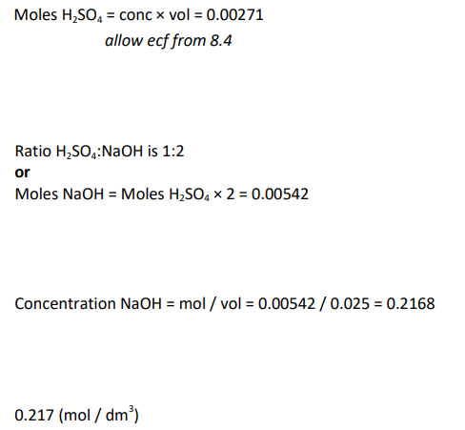
0.114 Concentration x 1000 cm³ of solution = moles of a substance x Mr

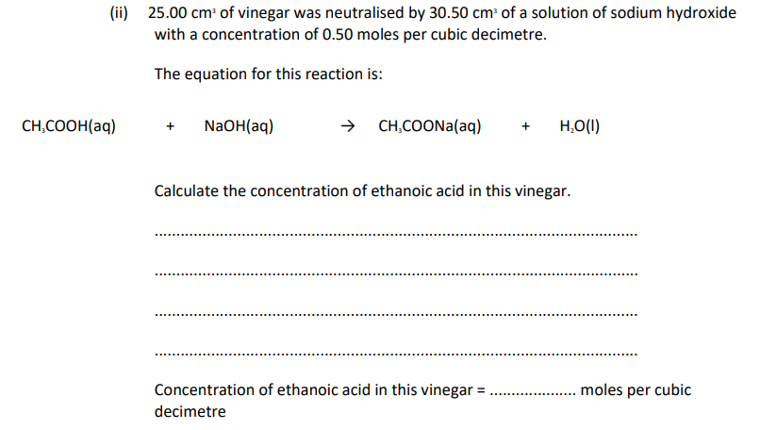0.61
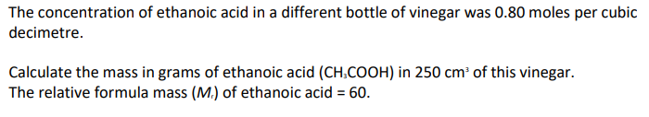 12
What is stoichiometry?
The relationship between the relative quantities of substances taking part in reaction or forming a compound typically a ratio.
Mole stoichiometry relates the ratios of two chemical substances in an equation
Formulas for a hypothetical equation
xA + yB --------> zC
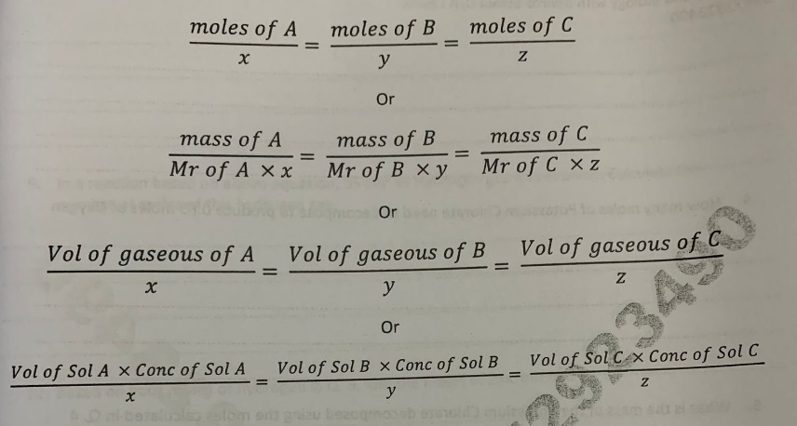
Balancing equations
Masses of reactants & products can be calculated from balanced symbol equations
Chemical equations can be interpreted in terms of moles. E.g., Mg + 2HCl -> MgCl2 + H2 shows that 1 mol Mg reacts with 2 mol HCl to produce 1 mol MgCl₂ and 1 mol H₂
Total moles of one element must be the same on both sides of the equation
Balance the following eq
H₂ + Cl –--- > HCl
N₂ + H₂ ----- > NH₃
- What mass of nitrogen is needed to produce 45.0 grams of ammonia 2x 45
- What volume of hydrogen gas can be used if 800 cm³ of ammonia gas is to be produced at rtp 0.05
Balancing numbers in a symbol equation can be calculated from the masses of reactants and products: a. convert the masses in grams to amounts in moles
b. convert the numbers of moles to simple whole number ratios, then you know how many moles you have of one element/compound compared to another
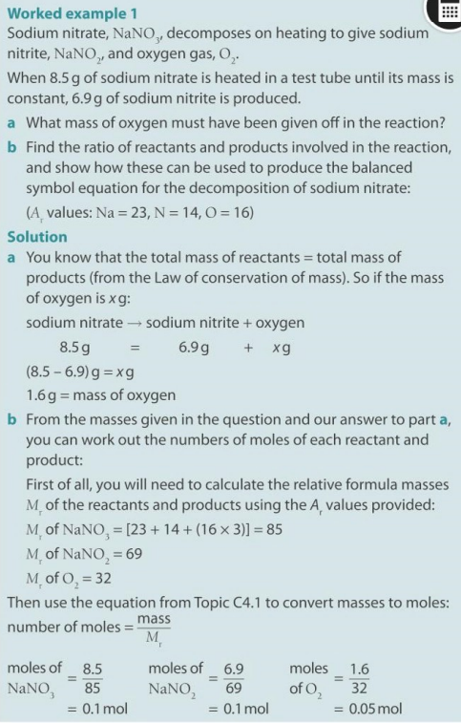
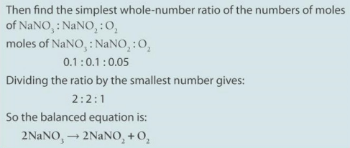

Percentage yield
All reactions do not achieve completion. This can be due to unavailability of proper conditions or due to contaminated over diluted solutions. Thus, the amount of product appears to be lower than predicted by the theoretical value.
% yield = (actual yield/ theoretical yield) x 100
Procedure to calculate % yield
  - Use mass/ volume/ concentration of reactants and molar ratios to calculate the amount of products
This is the theoretical yield
  - Than use this formula % yield = (actual yield/ theoretical yield) x 100
Short-hand formulas
Mass of reactant/ (Mr of reactant x Mole ratio) = (Mass of product/ Mr of product x Mole ratio) x yield
Volume of reactant/Mole ratio = (Volume of product/ Mole ratio) x yield
(Volume x concentration of reactant) x mole ratio = (volume x concentration of product / mole ratio) x yield
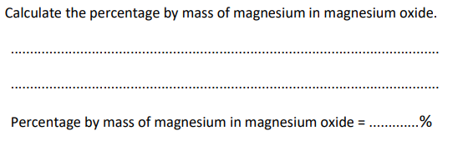
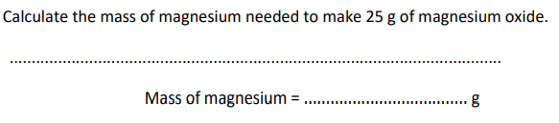
(24/ 24 + 16) x 100 = 60
15 = (24/40) x 25
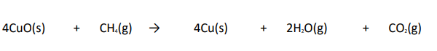
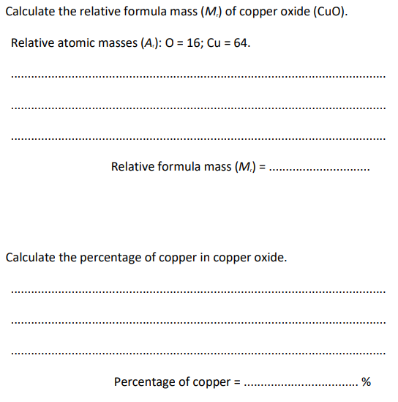
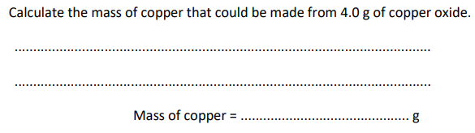
80, 80, 3.2
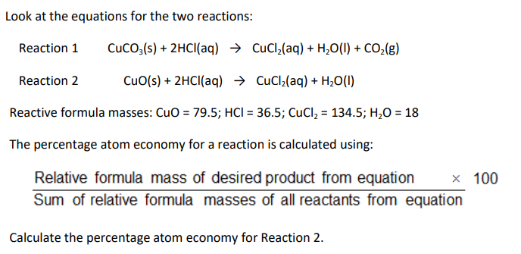
88.2
Limiting reactants
Limiting reactants are defined as the reactants which are not present in lesser amounts(moles) as compared to other reactants in the equation.
They limit the yield of products
The other reactants sometimes stay unreacted by the end of a reaction.
● In a chemical reaction with 2 reactants you will often use one in excess to ensure that all of the other reactant is used
● limiting reactant: the reactant that is used up / not in excess (since it limits the amount of products)
● If a limiting reactant is used, the amount of product produced is restricted to the amount of the excess reactant that reacts with the limiting one (so use amount of limiting reagent not one in excess for calculations)
Procedure to identify the limiting reactant
There are two ways for how to calculate limiting reagent. One method is to find and compare the mole ratio of the reactants that are used in the reaction. Another method is to calculate the grams of products produced from the quantities of reactants in which the reactant which produces the smallest amount of product is the limiting reagent.
Method 1: Finding the limiting reagent by looking at the number of moles of every reactant.
- First, determine the balanced chemical equation for the given chemical reaction.
- Then, convert all the given information into moles (by using molar mass as a conversion factor).
- The next step is to calculate the mole ratio from the given information. Then, compare the calculated ratio to the actual ratio.
- Use the amount of limiting reactant for calculating the amount of product produced.
- Lastly, if necessary, calculate how much of the non-limiting agent is left in excess.
Method 2: Finding the limiting reagent by calculating and comparing the amount of product each reactant would produce.
- The first step is to balance the chemical equation for the given chemical reaction.
- Then, convert the given information into moles.
- Use stoichiometry for each individual reactant for finding the mass of product produced.
- The reactant which produces a lesser amount of product would be the limiting reagent.
- The reactant which produces a larger amount of product would be the excess reagent.
- Lastly, for finding the amount of remaining excess reactant, subtract the mass of excess reagent consumed from the total mass given of the excess reagent.
Summary
If there are more than one reactant in an equation the following steps should be taken to identify the limiting reagent
- Calculate the moles of each reactant using above learned formulae based on given mass/gaseous volume/volume and concentration
- Apply mole ratio for each reactant individually to calculate the moles of product that can be produced
- Repeat the procedure with each reactant and calculate the moles of the product that can be produced
- The reactant that produces least amount/moles of the product is limiting reagent
QS
